

**Submitted by: Submitted to:**

**NAME: Rahul Gusain Hitesh Kumar Sharma**  
 **SAP: 500084143**  
 **ROLL NO.: R214220900**  
 **BATCH: 1 DevOps (N.HONS)**

# **Application Containerization and Orchestration**

**ASSIGNMENT 2**

**Q. Implement the following Scenario in Docker**

1. Create a Dockerfile

2. Pull an Ubuntu image in it.

3. Install python in it.

4. Echo a message “Hello Python”

5. Install Nginx server in it.

6. Build an image of this Dockerfile named as “your roll number”

7. Push that image on Docker Hub

8. Pull that image from Docker Hub

9. Run a container from this image

10. Create volume MyDvol for this container.

11. Create a file in this volume with a text message “Hello MyDvol”

**Solution**

# Creating Dockerfile

Solution: -

Create a Dockerfile.

**Command :- touch Dockerfile Command :- vi Dockerfile**

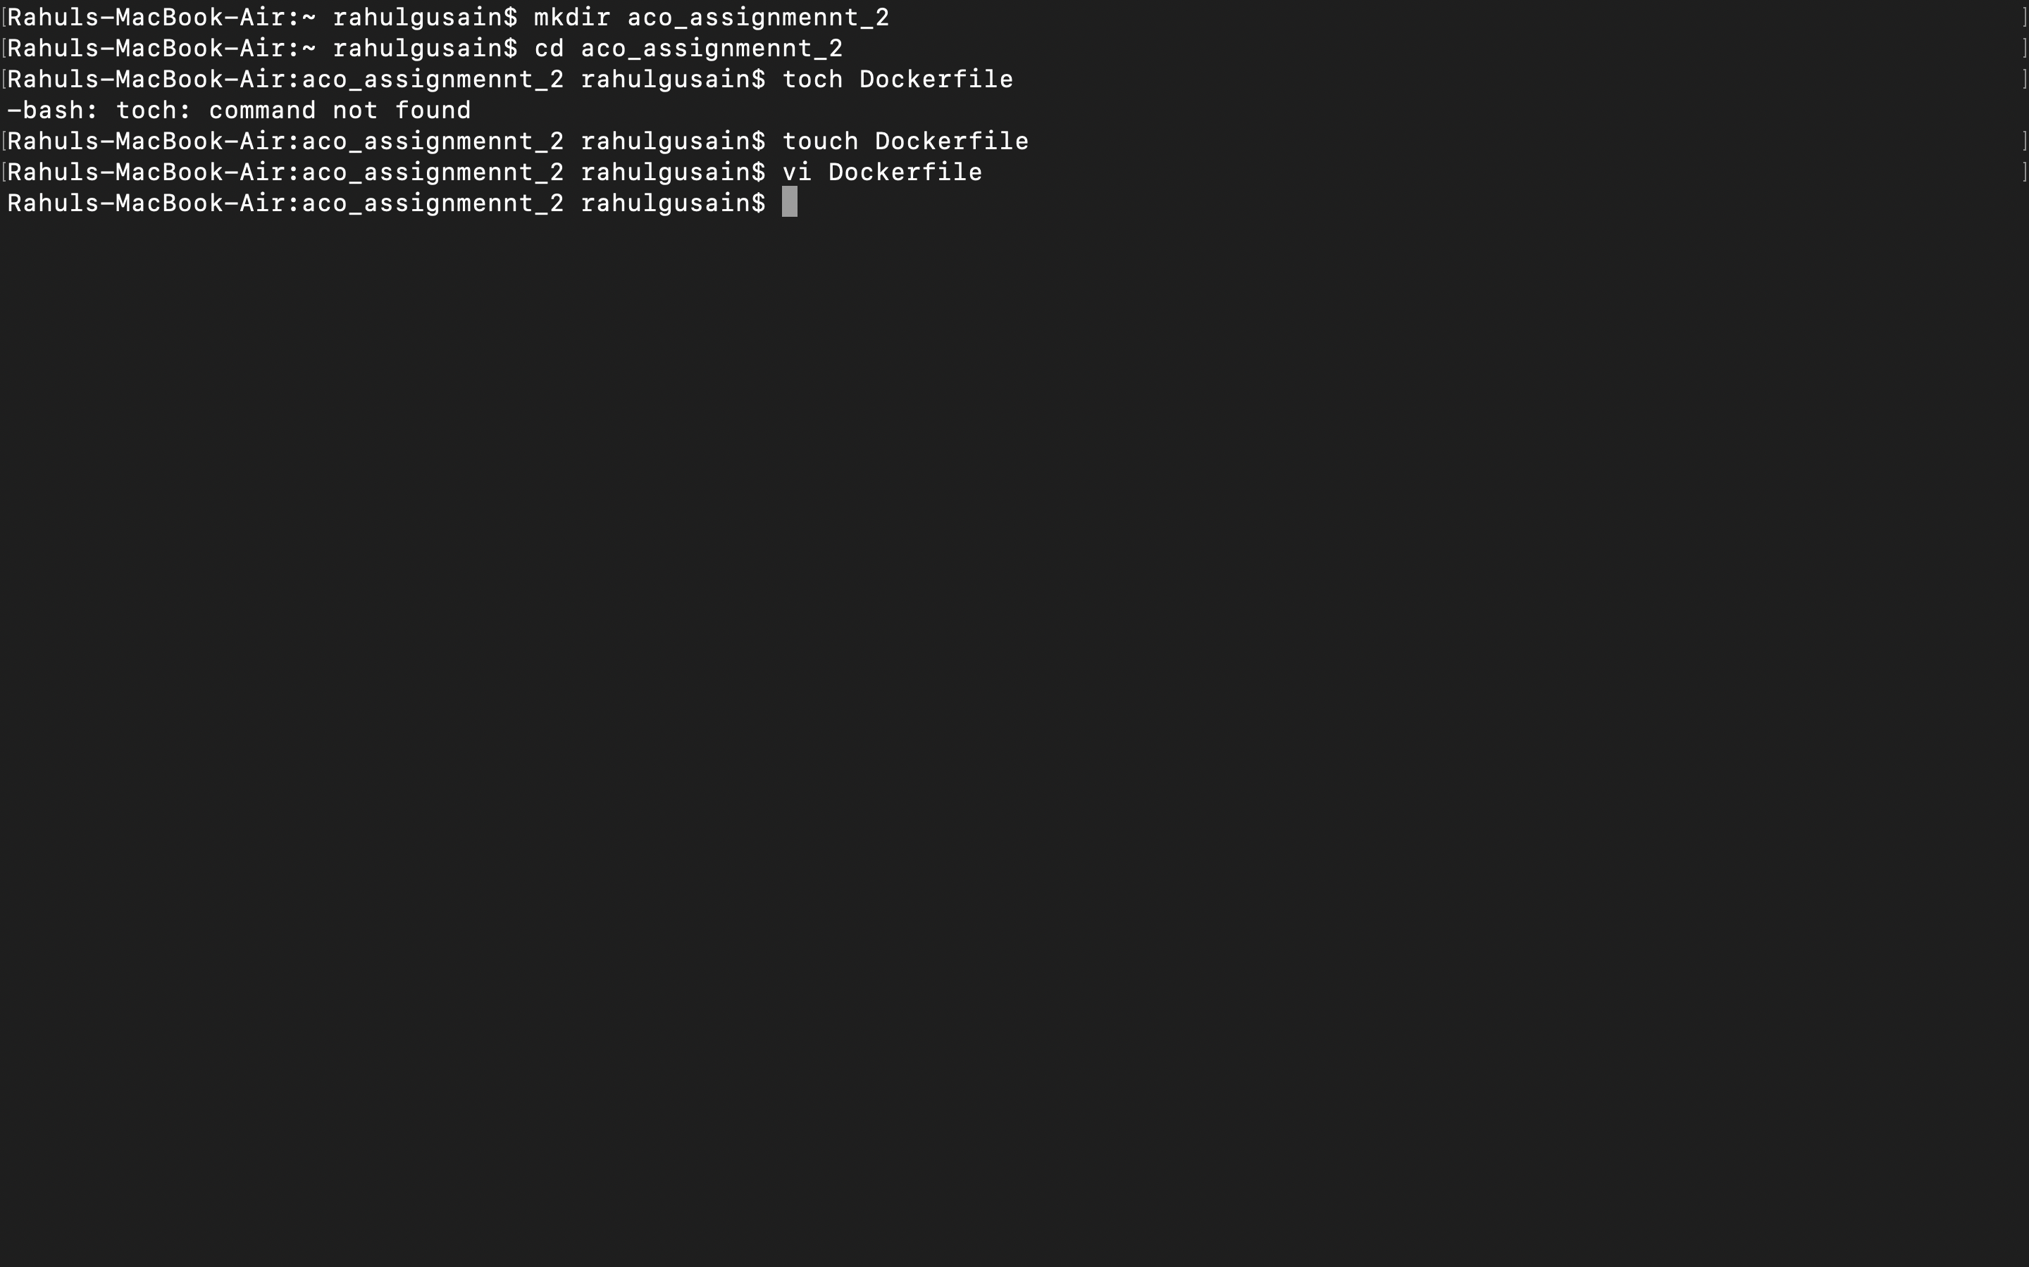

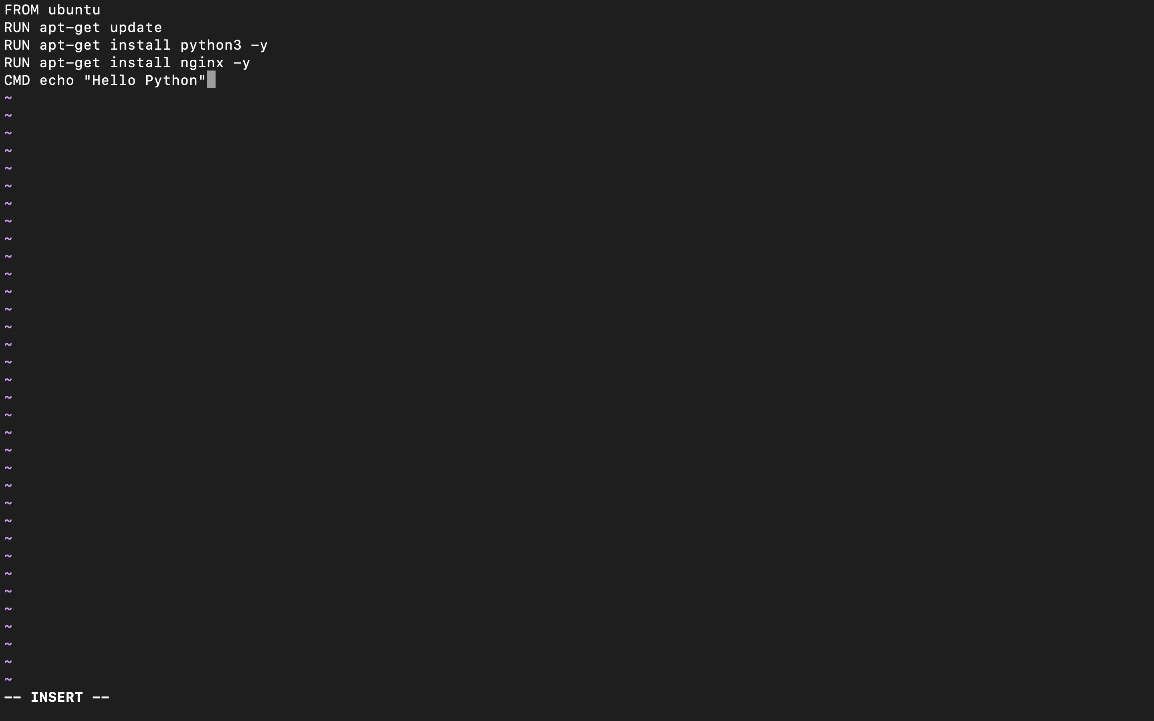

**Build an image of this Dockerfile named as “your roll number”**

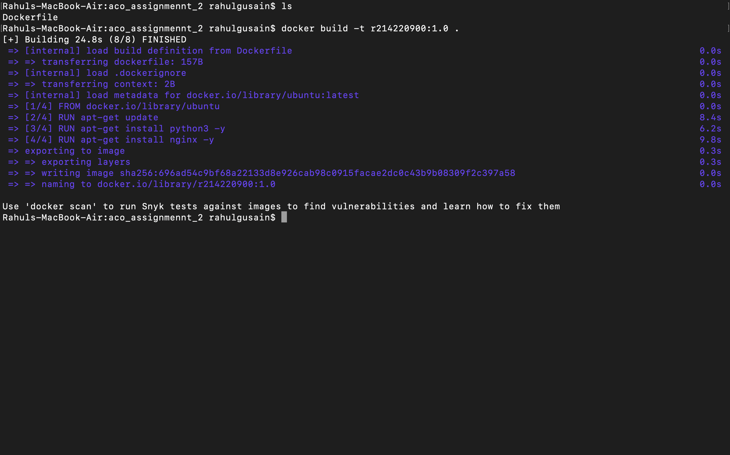

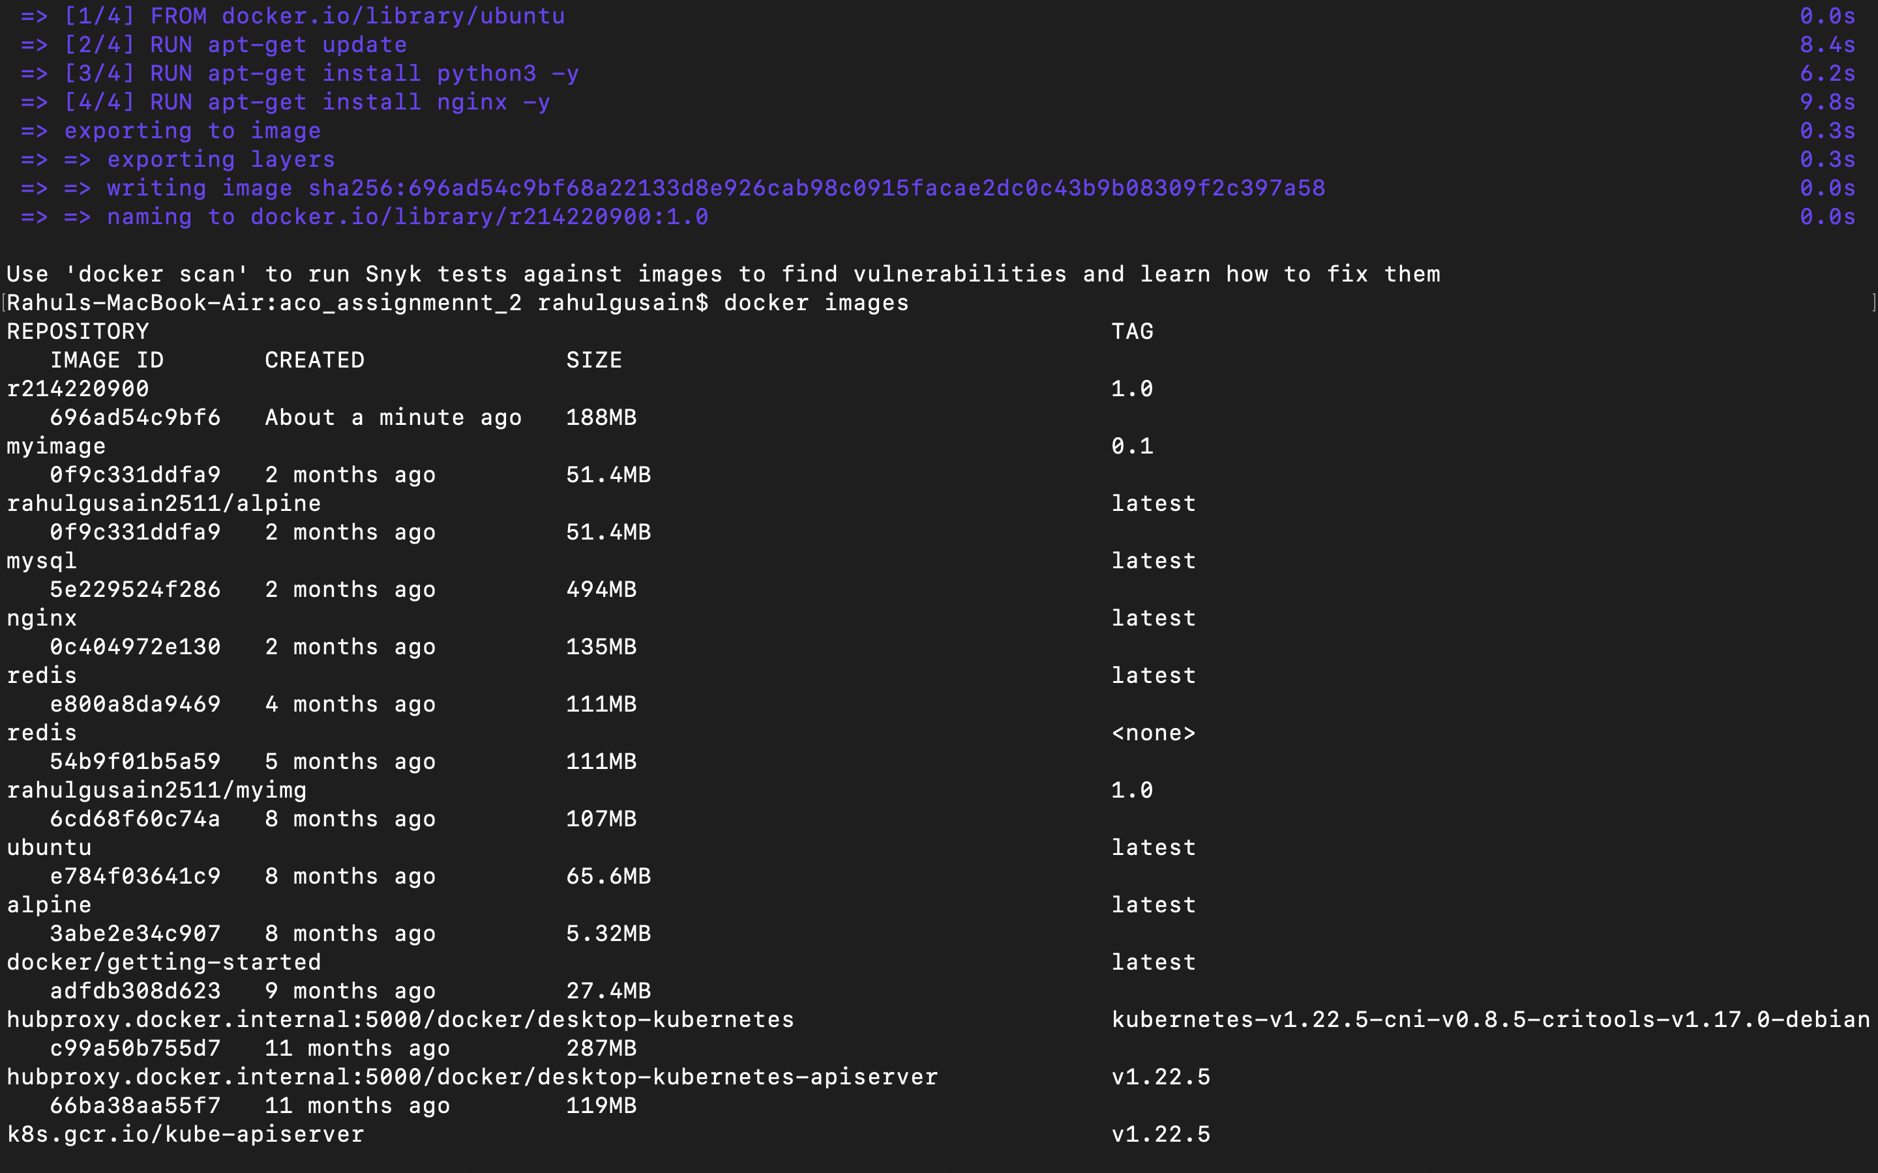

**Push that image on Docker Hub**

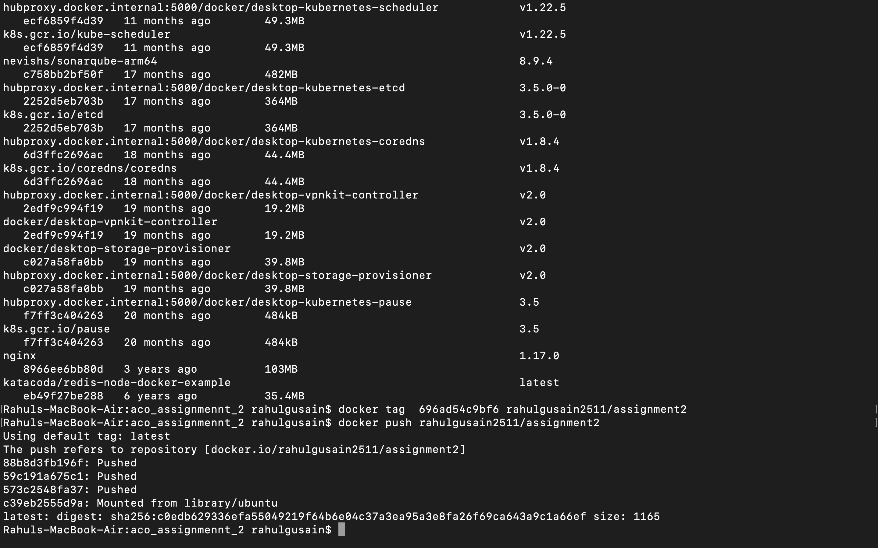

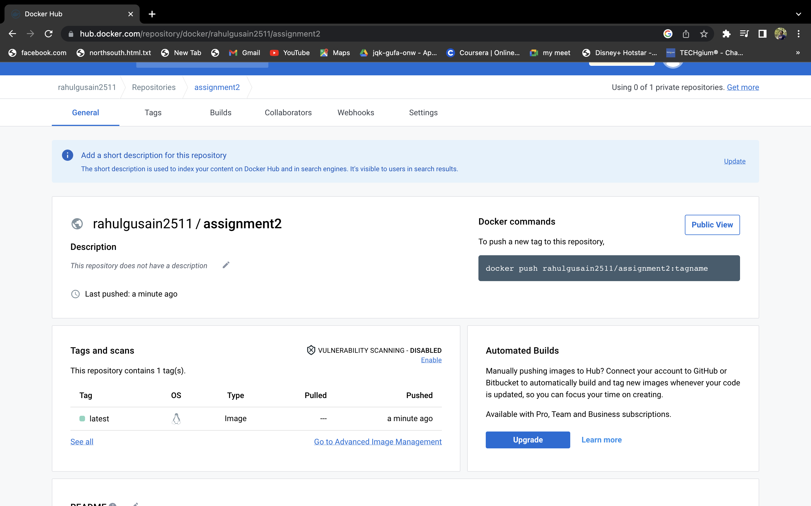

**Pull that image from Docker Hub**

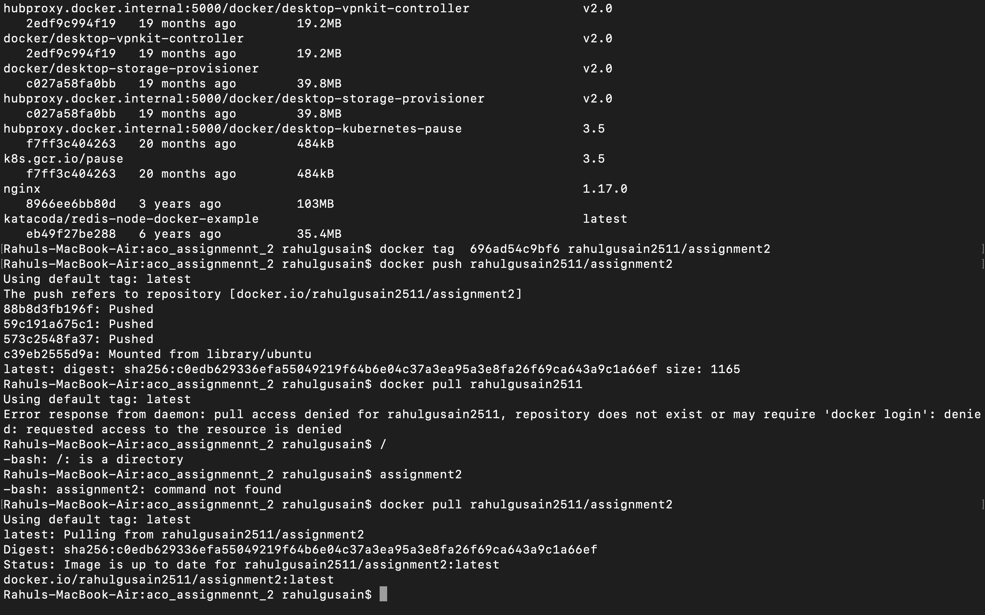

**Run a container from this image**

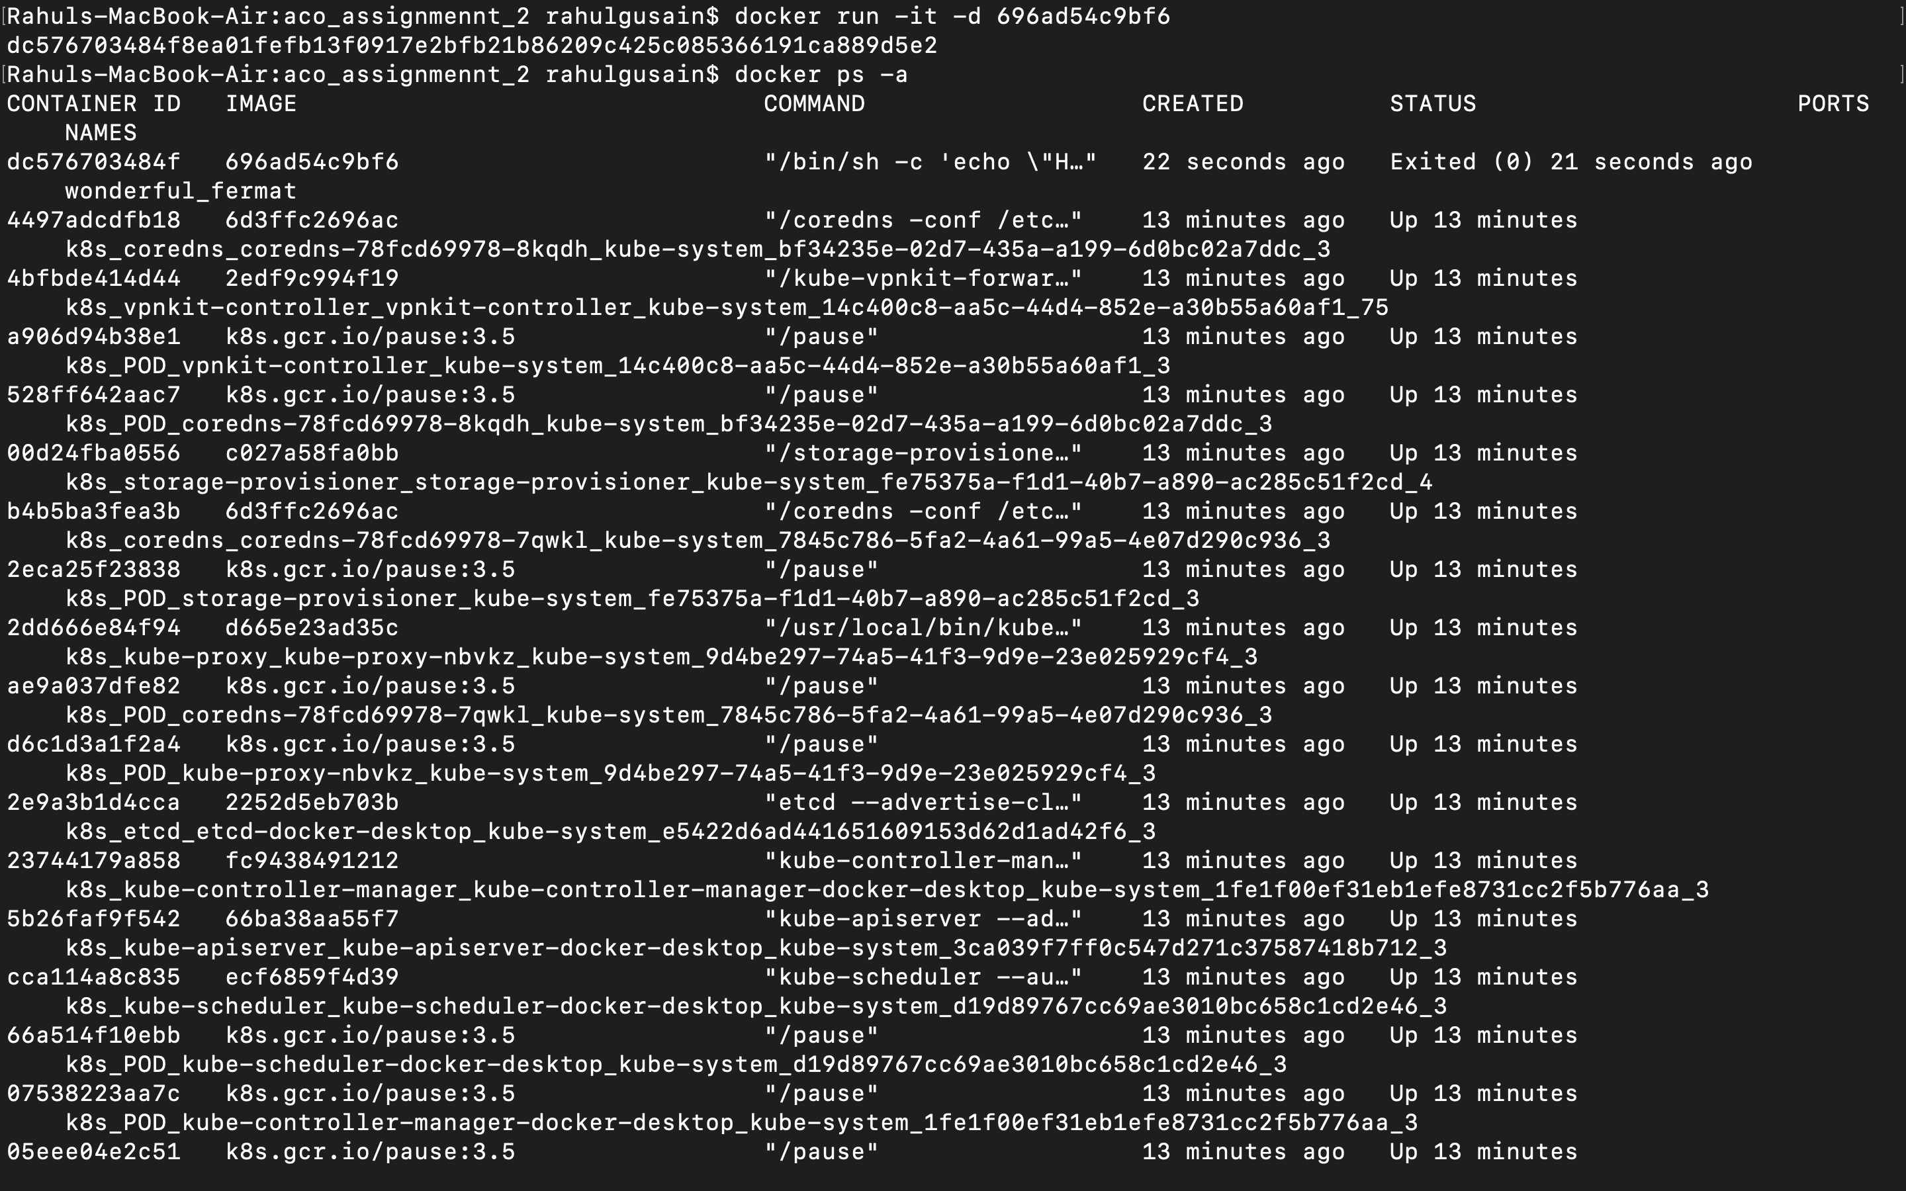

**Create volume MyDvol from this container**

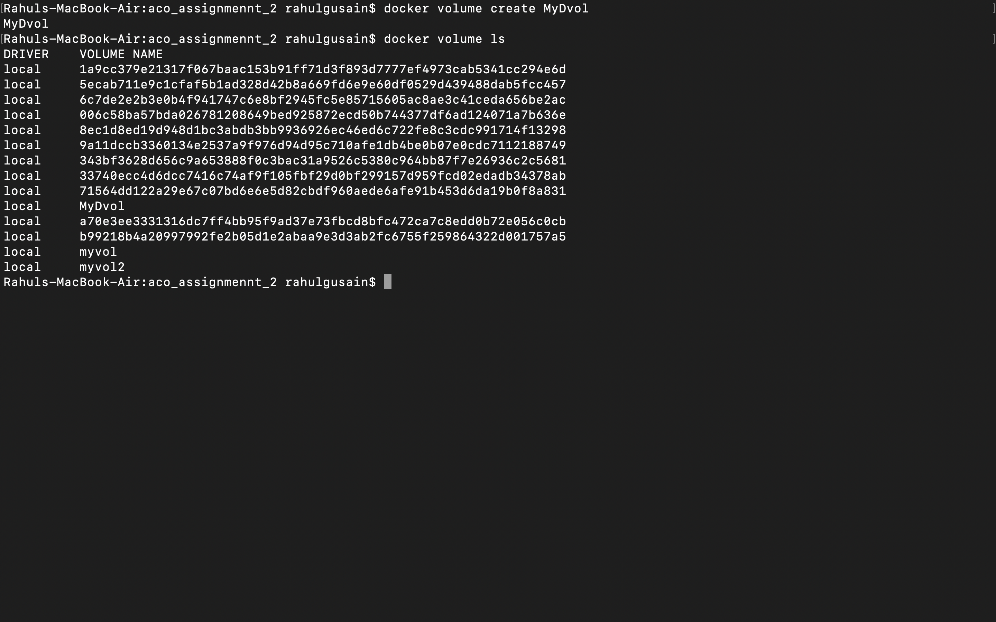

**Create a file in this volume with a text message “Hello MyDvol”**

